Name: ________________________________

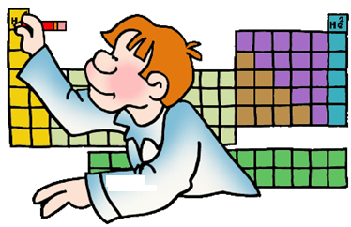

Date: _________________________________



**INTRODUCING THE PERIODIC TABLE**

1. What is the periodic table?
2. Who made the periodic table?
3. What ability did the periodic table have?

**INFORMATION ON THE PERIODIC TABLE**

1. How is each element represented on the periodic table?
2. Using the diagram below, label the parts of the element box.



1. In the shaded area to the right, draw the element box for the element that has an atomic mass of 107.87.
2. In the shaded area to the right, draw the element box for the element that has the element symbol Pt.

**ORGANIZATION OF THE PERIODIC TABLE**

1. How is the periodic table arranged?
2. What is each column on the periodic table called and how many of them are there?
3. What is each row on the periodic table called and how many of them are there?

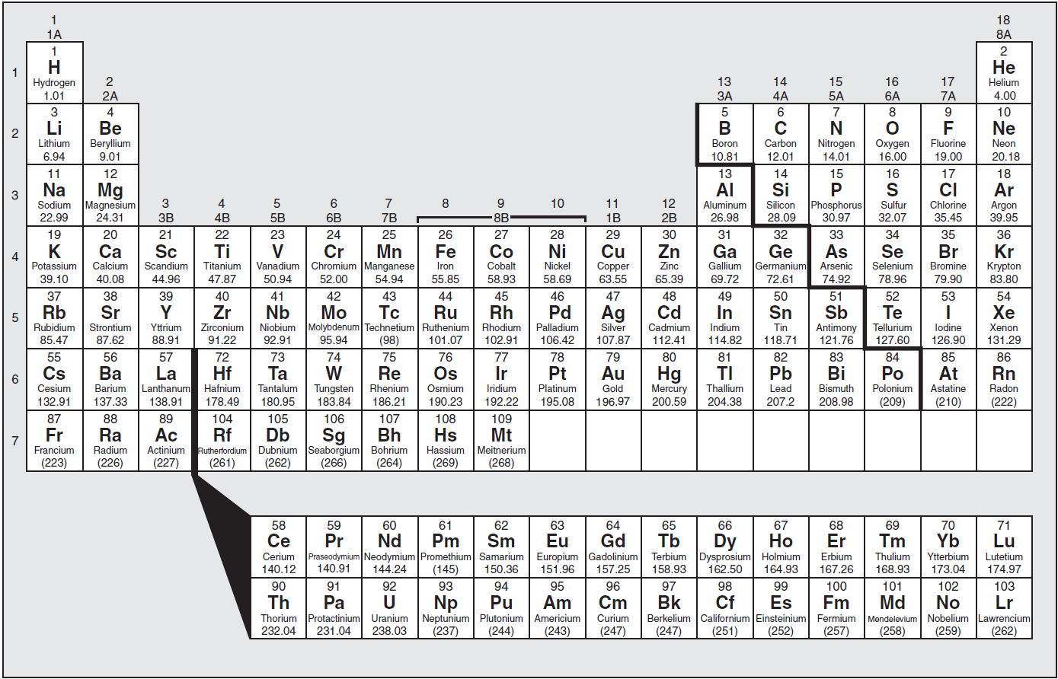

1. In the diagram able, identify and highlight the **zigzag** line. What is another name for the zigzag? Label it on the diagram above.
2. Describe where the **metals** are found on the periodic table. Label them “metals” on the diagram above.
3. Describe where the **non-metals** are found on the periodic table. Label them “non-metals” on the diagram above.
4. Which is the **only non-metal element** that is not located with the rest?
5. Where are the **metalloids** found and how many of them are there?

**METALS, NON-METALS AND METALLOIDS**

1. Fill in the chart below to **summarize** **the metals, non-metals and metalloids**.

|  |  |  |  |
| --- | --- | --- | --- |
| **Class of Elements** | **State of Matter** | **Properties** | **Examples of Elements** |
| Metals |  |  |  |
| Non-metals |  |  |  |
| Metalloids |  |  |  |

**CHEMICAL FAMILIES ON THE PERIODIC TABLE**

1. What is a **chemical family**?
2. What are the name of the 4 chemical families that we have learned in class?
3. Fill in the chart to **summarize** information on important groups on the periodic table.

|  |  |  |  |
| --- | --- | --- | --- |
| **Name of Group** | **Group #** | **Examples of Elements in this Group**  **(use symbols)** | **Description of Properties and Facts** |
| alkali metals |  |  |  |
| alkaline earth metals |  |  |  |
| halogens |  |  |  |
| noble gases |  |  |  |

